Table of Contents
Table of Contents 1
GTPlot Solution 2
Map Product 2
Sample Map Product Output: 2
Map Product Metadata 3
G/Technology Out of the Box 4
Placing Plot Boundaries (G/Technology out of the box) 4
New Plot Window (G/Technology out of the box) 4
Workspace Plots (G/Technology out of the box) 5
Industryware Enhanced Plot Solution 6
Plot Boundary Placement 7
PlotBoundaryIPT (Placement Technique) 7
PlotBoundaryLabelSPT (Silent Placement Technique) 8
Generating a New Plot Window (Custom Command) 9
New Plot Window – Plot Boundary Tab 9
New Plot Window – User Defined Plot Tab 10
Managing Workspace Plots 11
Workspace Plots (G/Technology out of the box) 11
Workspace Plots (Custom Command) 11
Future Enhancements: 12
Generic: 12
Plot Boundary Placement: 12
New Plot Window: 12
Workspace plots: 13
Plot Boundary Feature 13
Product TRs 13
Product CRs 13
Requests Submitted to Expose Product API 14
New Plot Window… 14
Workspace Plots… 14
Plot Boundary Info View 15
VGC_WRKBND_PLOT (Example) 15
APL Metadata Tables ER Diagram 16
APL METADATA 17
APL_SHEETS 17
APL_DRAWINGINFO 17
APL_GROUPS_DRI 18
APL_MAPFRAME 18
APL_REDLINES 19
APL_LEGEND_OVERRIDE_GROUPS 20
APL_LEGEND_OVERRIDE_ITEMS 20
APL_PARAMETERS 20

GTPlot Solution
The GTPlot solution consists of various placement techniques and custom commands used to automate the production of various types of Map Product plot outputs. Map Products are automatically generated within G/Technology Named Plot Windows that are saved in workspaces.

Map Products
Map product could be categorized as one of the following.
- City Approvals
- Field Construction Work
- Underground Construction
- Overhead Construction
- Field Check

All map products are defined using metadata stored in Oracle tables therefore GIS system administrators can easily manipulate map products using SQL. GTPlot metadata defines and stores each Map Product and the many elements they may contain. Administrators can configure Map Products to contain the following elements to be automatically placed within a given Named Plot Window:

- Sheets of various sizes
- Border Inset
- Redlines – Groups of Polyline, Symbols and Text including Automatic Fields.
- Map Frames – including key maps w/default legend and optional north arrow.
- Objects – OLE embedded objects.

Sample Map Product Output:
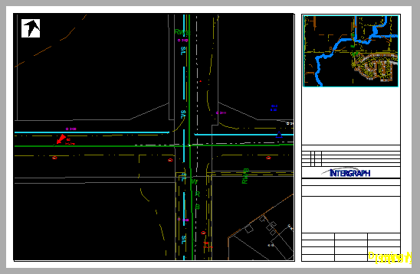

Map Product Metadata
Changes to GTPlot Map Products are done by manipulating the following GT_PLOT_* metadata tables that drive the Plot Boundary placement technique, New Plot Window and Print Active Map Window custom commands.

- GT_PLOT_PARAMETER – Defines a number of parameters used by the GTPlot software.
- GT_PLOT_SHEETS – Defines the different sheet names, sizes and their dimension.
- GT_PLOT_DRAWINGINFO – Defines each drawing type with each sheet definition, default scale and inset defining the plot border.
- GT_PLOT_GROUPS_DRI – Defines the redlines, mapframes and OLE object to include for each drawing type along with the placement of each.
- GT_PLOT_REDLINES – Defines groups of redlines (Title Block, Revision History, Legend, Source Document Info)
- GT_PLOT_MAPFRAME – Defines Map frame and Keymap size, location and north arrow
- GT_PLOT_OBJECTS – Defines objects to be embedded into the plot (Logo)

G/Technology Out of the Box
Current steps required using G/Technology out of the box functionality to create a customer’s standard everyday plot.

Placing Plot Boundaries (G/Technology out of the box)
Placing of Plot Boundaries can be:
- ADHOC drawn (Not very useful if attempting a target output of specific Paper Size, Paper Orientation and Map Scale)
- Hierarchy of multiple placement selection. Each selection having a preconfigured polygon placement technique with a set Paper Size, Paper Orientation and Map Scale.
Sample placement selected:
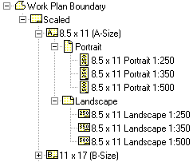
...

New Plot Window (G/Technology out of the box)
- Create a new plot window
  - Select \Window \New Plot Window
  - Select Use existing plot
  - Define a plot name.
  - Select from one of many templates at various Paper Sizes and Paper Orientations.
  - Select OK
- Update Plot Fields
  - Right Click on plot window and select Sheet Properties.
  - Update the lengthy Oracle SQL query in the Associate Query to Plot entry field to include the name of the referencing plot boundary on the map.
  - Select OK
  - Select \Plotting \Update Plot Fields to update the field values with that of the referenced polygon plot boundaries values.
- Select the Insert Map Frame button
  - Select the Top Left and Bottom Right point to define Map Frame location.
  - Select Map \ Legend to be used.
  - Select OK
- Fit the plot boundary polygon within the map frame.
  - Double Click on the Map Frame to make it active.
  - Navigate to the referenced polygon plot boundary and select it.
  - Select Fit Selected to center the map’s plot boundary polygon within the Map Frame.
  - Verify scale and fix if necessary.
  - Click off the map frame to un-select.
- To show a north arrow. Select \View\North Arrow Properties.
  - Select the Browse button and locate the appropriate north arrow symbol.
  - Define a number of north arrow properties… Size Color, etc.
  - Associate the north arrow to a plot map frame.
  - Select OK
- Select \View\Rotate Map to rotate the map window content to the correct angle.
- Right Click on plot window and select Sheet Properties.
  - Select and appropriate Style substitution.
  - Select OK
- Adjust Legend to show/hide or filter a number of components.

Recording of workflow:

If there is anyone out there willing to volunteer please let me know?

Workspace Plots (G/Technology out of the box)
The existing Workspace Plots command allows users to Delete or Rename a single workspace plot.
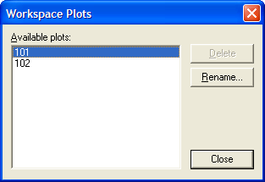

Industryware Enhanced Plot Solution
The plotting solution consists of three areas of automation involving the use of the following Placement Techniques, Functional Interfaces and Custom Commands:

- Plot Boundary Placement
  - PlotBoundaryIPT (Placement Technique)
  - PlotBoundaryLabelSPT (Silent Placement Technique)

- Generating a new Plot Window
  - New Plot Window (Custom Command)

- Managing Workspace Plots
  - Workspace Plots (Custom Command)

Plot Boundary Placement
Plot Boundary placement is used to automate the placement of boundary geometries at a predefined Paper Size, Orientation and Map Scale.

PlotBoundaryIPT (Placement Technique)
The plot boundary placement technique aids users in placing a polygon that covers the work area they would like to print.
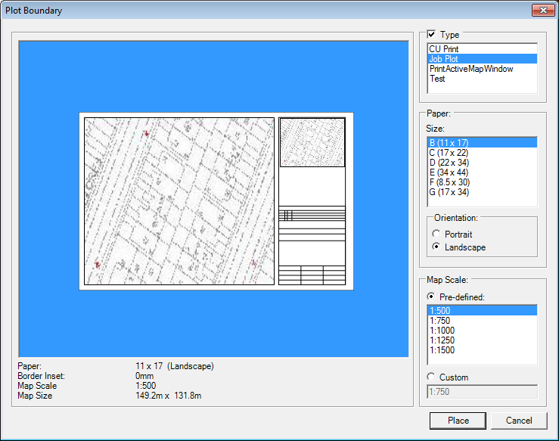
Functionality:
- Multiple Map Product types supported.
- Displays coverage size in ground units.
- Predefined or custom scales.
- Place rotated Plot Boundary by using the Ctrl and/or Shift keys during placement for varying degrees of rotation precision.
- Quickly redefine the Type, Size or Scale when dragging the boundary by simply selecting the TAB key.
- Updates some of the plot boundary feature’s attributes:
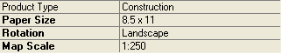
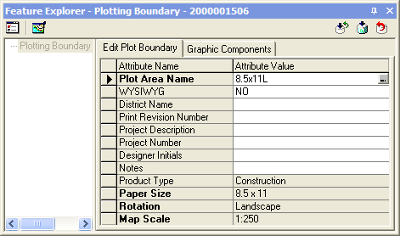

PlotBoundaryLabelSPT (Silent Placement Technique)
This SPT is used to auto place a label in center of the boundary. This helps the users to easily identify each boundary from a distance and is generally only visible above a scale of 1:1000.
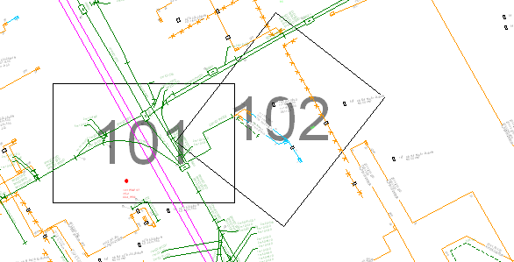

Generating a New Plot Window (Custom Command)
The New Plot Window custom command is used to automate the creation of plot windows and its contents based on metadata configuration. Plot Windows can be User Defined or generated using a Plot Boundary placed in the Map Window.

New Plot Window – Plot Boundary Tab
The Plot Boundary tab is used to creating one or more plots from plot boundaries placed in a given job.
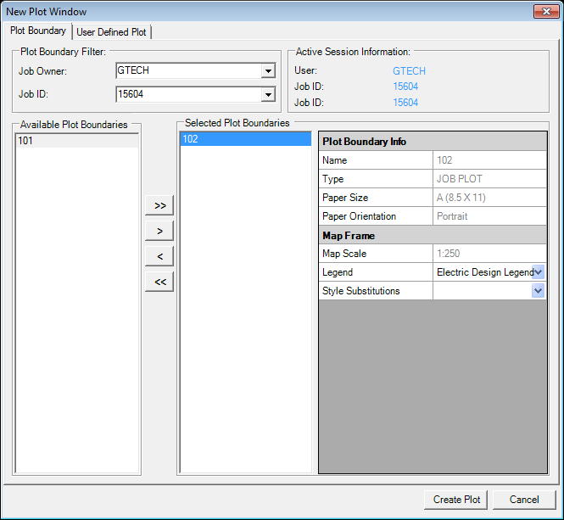

Functionality:
- Default or selectable Legend
- Style substitution
- Legend Overrides
- Auto Insertion of the following based on metadata configuration:
  - Grouped Redlines (Title Block, Notes, etc.)
  - Border
  - MapFrame with given polygon’s content at the specified scale and map rotation.
  - KeyMapFrame with given polygon’s content at the specified scale and map rotation that is usually higher than the MapFrame content. A different legend can be used with less data to remove clutter.
  - Insertion of OLE objects like company logo.
  - North Arrow

New Plot Window – User Defined Plot Tab
The User Defined Plot tab is used to creating a single plot from a number of user inputs. Because the source data is not being derived from a plot boundary the user is presented with a list of automatic fields inputs.
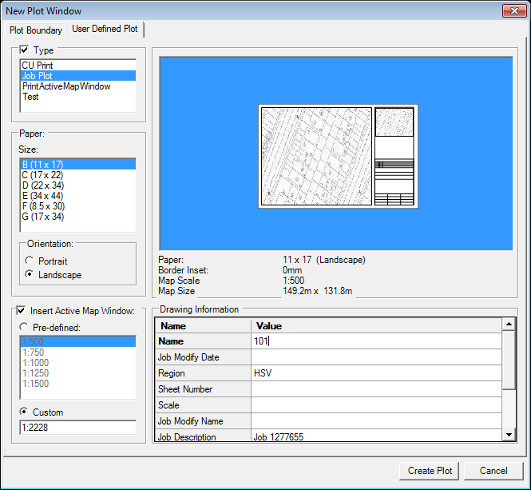

Managing Workspace Plots
The workspace plots custom command aids users to manage and perform operations on named plots store in the current workspace.

Workspace Plots (G/Technology out of the box)

Workspace Plots (Custom Command)
Functionality from the out of the box New Plot Window command was moved to the new Workspace Plots custom command to support batch operations on workspace plots through the use of a multi selectable list.
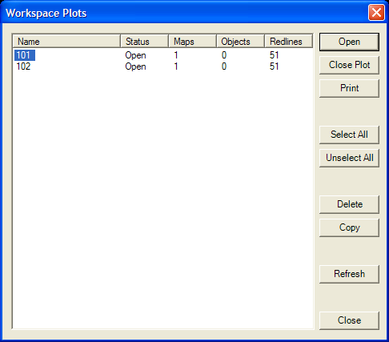
Perform the following in batch using a multi select list:

  - Open
  - Close
  - Delete
  - Print

Future Enhancements:

Generic:
- Support for Imperial
- Sizable dialogs and persist sizing
- Create a new custom command to allowing users to place miscellaneous groups of redlines from a library interactively on an existing plot.
- Expose the Legend Override functionality out into its own custom command. This will allow users to discard or change the overrides after the plot has been created.
- Done -Move Table and Column definition from code constants and out to metadata.
- Done -Move Plot Query from code to view
- Done -Persist dialog position and last used values

Plot Boundary Placement:
- Add support for ADHOC Plot Boundary placement. (Add Place irregular/user defined polygon button to PlotBoundaryIPT placement technique)
- Plot Preview Window - Add each template’s redline TEXT to the display. Issue with sizing fonts.
- Enhanced placement of multiple Plot Boundaries based on an area or linear path auto numbering/naming each along the way.
  - Identify a linear path to place multiple polygons along.
  - Identify an area to auto place a grid of polygons within.

New Plot Window:
- New Plot Window custom command is missing the option to automatically generate a map window grid of formations that exist in the detail. Bell Canada currently has this functionality in the old VBA plotting solution.
- Auto insertion of the Scale Bar
- Attributes (Misc adhoc Values) - SUPPORT for misc field values that do not exist in PlotBoundary feature for the user to manually input. Ie. Notes
- Done -User Defined Plot – Add the preview plot template display window that used during placement of Plot Boundaries.
- Done - Use of Plot Field so that Update Plot fields work. Query already stored. Implement AutomaticTextField, can use gtpatMapFrameByScale for the Maps Scale and others are available to shoe current user and date.
- Done -Add support for ADHOC Plot Boundary placement. (Will enable the user to define the Page size, orientation and Scale before creating the plot because it’s not defined during placement of ADHOC plot boundaries.)
- Done -Auto insertion of predefined Map Objects.

Workspace plots:
- Batch print to PDF
- Open/Save redline templates to metadata.

Plot Boundary Feature
- Done - Place a rotated plot boundary then have the New Plot Window command insert a Map Window with its contents rotated.

Product TRs
- No Right Click event raised in Placement Tech. Discovered that this is a WAD.

Product CRs
- Insert a Map Window with its contents rotated. Ability for Rotate the contents of a Map Window through the API
- Legend Overrides – Access to change an existing legend’s properties.
- Auto insertion of the Scale Bar and North Arrow including position, size, etc.
- Rotate a plot window’s MapView content.
- Need Plot Window Close/Open/Focus event to refresh workspace plots list.
- See next page for additional details:

Requests Submitted to Expose Product API
For the plotting solution I have a number of CRs that I’m going to file with Cam to publicly expose product API. Unsupported API was used in the New Plot Window custom command and additional API support is required for Workspace Plots solution.

New Plot Window…
- Legend Overrides
  - oLegEntry.Name
  - oLegEntry.DisplayMode = True
  - oLegEntry.Filter = "CLASS<>'5'"
  - An update/refresh for each legend entry change needs to be currenlty issued. It would be faster to be able to apply filters to many legend entries in batch with a single update/refresh when done.
- Insert North Arrow
  - oPlotSheet.InsertNorthArrow()
  - oNorthArrow Properteis
    - .MaintainRelativePosition
    - .UserDefinedAzimuth
    - .SymbolFile
    - .Size
    - .MapViewID
    - .Refresh
    - Location of North Arrow required.
- Rotate Map View
  - oMapView.Rotate(dAngle)
  - oMapView.Refresh()
- Zoom To Fit Page - Fitting the Plot Sheet in the Plot Window
  - oPlotWindow.ZoomToFit() – Zoom Fit doesn’t always fit the entire page. Scroll bars are sometime left.
  - oPlotWindow.ZoomOut()

Workspace Plots…
- Need Plot Window Close/Open/Focus event to refresh workspace plots list.
- Expose API to print to PDF using products internal 3rd party PDF write. CR on file.

Plot Boundary Info View
The following view is used by the NewPlotWindow custom command to retrieve all of the column info required to generate the redline text.

VGC_WRKBND_PLOT (Example)

DROP VIEW VGC_WRKBND_PLOT;

CREATE OR REPLACE FORCE VIEW VGC_WRKBND_PLOT (
G3E_ID, G3E_FNO, G3E_FID, G3E_CNO, G3E_CID,
PLAN_ID, ORIGINATOR, PHONE, ASSOCIATE_NAME, ASSOCIATE_PHONE,
ROW_NUMBER, ISSUE_DATE, REISSUE_DATE,
PLOT_SIZE, PLOT_SCALE, PLOT_ORIENTATION,
JOB_ID, JOB_STATE, FEATURE_STATE, SAP_WRK_ID,
WORK_ORDER_ID,
SWITCH_CENTRE_NAME,
"SYSDATE"
)
AS
SELECT A.G3E_ID,
A.G3E_FNO,
A.G3E_FID,
A.G3E_CNO,
A.G3E_CID,
A.PLAN_ID,
A.ORIGINATOR,
A.PHONE,
A.ASSOCIATE_NAME,
A.ASSOCIATE_PHONE,
A.ROW_NUMBER,
A.ISSUE_DATE,
A.REISSUE_DATE,
A.PLOT_SIZE,
A.PLOT_SCALE,
A.PLOT_ORIENTATION,
B.JOB_ID,
B.JOB_STATE,
B.FEATURE_STATE,
B.SAP_WRK_ID,
C.WORK_ORDER_ID,
D.SWITCH_CENTRE_NAME,
TO_CHAR (SYSDATE, 'YYYY/MM/DD') "SYSDATE"
FROM GC_WRKBND A,
GC_NETELEM B,
G3E_JOB C,
REF_EXCH D
WHERE B.G3E_FNO = 1500
AND A.G3E_FID = B.G3E_FID
AND B.JOB_ID = C.G3E_IDENTIFIER
AND B.SWITCH_CENTRE_CLLI = D.SWITCH_CENTRE_CLLI;

DROP PUBLIC SYNONYM VGC_WRKBND_PLOT;
CREATE PUBLIC SYNONYM VGC_WRKBND_PLOT FOR VGC_WRKBND_PLOT;

GRANT DELETE, INSERT, SELECT, UPDATE ON VGC_WRKBND_PLOT TO DESIGNER;
GRANT SELECT ON VGC_WRKBND_PLOT TO FINANCE;
GRANT SELECT ON VGC_WRKBND_PLOT TO INTERFACE;
GRANT SELECT ON VGC_WRKBND_PLOT TO MARKETING;
GRANT SELECT ON VGC_WRKBND_PLOT TO PUBLIC;
GRANT SELECT ON VGC_WRKBND_PLOT TO SUPERVISOR2;

APL Metadata Tables ER Diagram
The following diagram requires some updates to include columns added to support Auto Insertion of North Arrows.
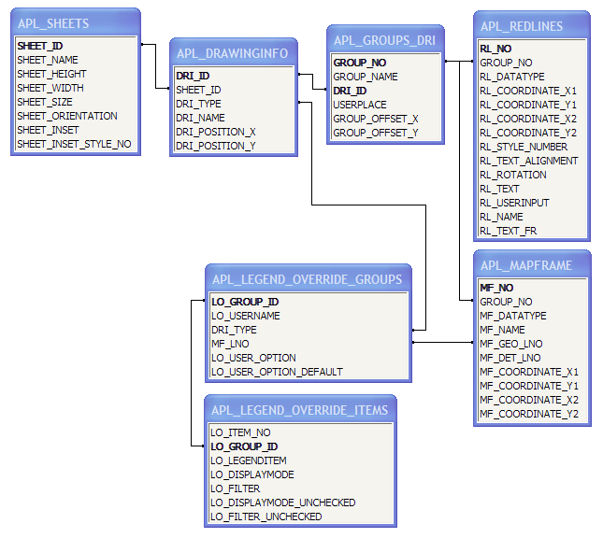

APL METADATA
There are 7 APL tables that define the metadata for the custom plot command. The following list may not be up to date. Updates are required to include columns added to support Auto Insertion of North Arrows.

APL_SHEETS
This table defines the different sheet sizes and their dimension and inset defining the plot border. There are 10 sheets defined (A size thru E size, each with a landscape and portrait orientation).

SHEET_ID unique sheet ID
SHEET_NAME A thru E sizes
SHEET_HEIGHT sheet size in mm
SHEET_WIDTH sheet size in mm
SHEET_SIZE sheet size description in imperial units
SHEET_ORIENTATION Portrait or Landscape
SHEET_INSET white space between edge of sheet and plot border
SHEET_INSET_STYLE_NO g3e_linestyle.sno of the inset /border

APL_DRAWINGINFO
This table defines each drawing type with each sheet definition.

DRI_ID: unique drawing info ID
SHEET_ID: from APL_SHEETS.sheet_id
DRI_TYPE: defines types of plots when placing a plot boundary
DRI_NAME: description (includes size and orientation eg: C-Size Portrait)

APL_GROUPS_DRI
This table defines areas in the plot sheet for placement of the map frame and redlines.

GROUP_NO: group ID
GROUP_NAME: description
format = sheet_size ||orientation || [dri_type] ||group type
DRI_ID: from APL_DRAWINGINFO.dri_id
Each DRI_ID can have a Map Frame definition. DRI_ID that will have a title block need a
Redline definition. Drawing Info Notes is an example of a redline grouping for multiple types.
USERPLACE: for Future use; not implemented
0 means automated by custom command; 1 means ad hoc user placed
GROUP_OFFSET_X coordinate in mm from top left edge of paper
GROUP_OFFSET_Y coordinate in mm from top left edge of paper

APL_MAPFRAME
This table defines the legend and the map frame for the plot sheet to be used when creating the Plot Window. Create unique Group_NO and MF_NO for multiple plot legends.

MF_NO unique map frame ID
GROUP_NO APL_GROUP_DRI.group_no
Every unique group_no for Map Frame types requires a definition
MF_DATATYPE For future use
MF_NAME Description
MF_GEO_LNO G3E_LEGEND.g3e_lno (the number for the Geo legend)
MF_DET_LNO G3E_LEGEND.g3e_lno (the number for the Detail legend)
MF_COORDINATE_X1 Top Left X of Map Frame
MF_COORDINATE_Y1 Top Left Y of Map Frame
MF_COORDINATE_X2 Bottom Right X of paper
MF_COORDINATE_Y2 Bottom Right Y of paper

APL_REDLINES
This table defines the redlines for the titleblock, etc. Units are mm.

RL_NO unique redline ID
GROUP_NO from APL_GROUPS_DRI.group_no
RL_DATATYPE Redline Text, redline Lines or redline Points
RL_COORDINATE_X1 Start Point from APL_GROUPS_DRI.group_offset_x
RL_COORDINATE_Y1 Start Point from APL_GROUPS_DRI.group_offset_y
RL_COORDINATE_X2 End Point from APL_GROUPS_DRI.group_offset_x
RL_COORDINATE_Y2 End Point from APL_GROUPS_DRI.group_offset_y
RL_STYLE_NUMBER g3e_sno from g3e_linestyle, or g3e_pointstyle or g3e_textstyle
RL_TEXT_ALIGNMENT if redline is a text item, set the alignment within the coordinates defined
1 = justification left
2 = justification center
3 = justification right
RL_ROTATION rotation of redline text and points
RL_TEXT text displayed in the titleblock
explain []
RL_USERINPUT future use; not implemented
RL_NAME future use; not implemented
RL_TEXT_FR French representation of text

APL_LEGEND_OVERRIDE_GROUPS
This table defines the overrides available in the New Plot Window. (see figure 2)

LO_GROUP_ID unique legend over ride group ID
LO_USERNAME description
DRI_TYPE APL_DRAWINGINFO.dri_type
MF_LNO G3E_LEGEND.g3e_lno (the number for the legend used for the plot window)
LO_USER_OPTION 1 means the user has the option of setting this override (greyed or not)
LO_USER_OPTION_DEFAULT default setting for this override (on or off)

APL_LEGEND_OVERRIDE_ITEMS
This table defines the legend items that are grouped together for each legend override.

LO_ITEM_NO unique legend item ID
LO_GROUP_ID APL_LEGEND_OVERRIDES_GROUPS.lo_group_id
LO_LEGENDITEM g3e_legenditem
LO_DISPLAYMODE visible to user turn on/off legend item when use a filter, always on
LO_FILTER filter for the legend item
LO_DISPLAYMODE_UNCHECKED turn off/on legend item
LO_FILTER_UNCHECKED filter for the legend item

APL_PARAMETERS
This table defines admin configurable parameters used by the GTPlot software.

PAR_DESCRIPTION parameter description
PAR_VALUE parameter value
PAR_EDITDATE date the last edited

